Action Research @HVC 2016/17

Teacher:
TLC partners
TLC
Focus
Target Class
Target students /cohort

Contents
TLC Process Timeline 3
Definition of Action Research 3
Action Research Cycle 4
TLC meeting 1: Action Research focus: 5
Initial Thoughts about a focus 6
TLC meeting 2: literature Review based on your broad focus. 7
TLC meeting 3: Refining a focus and Action Plan. 8
Action research plannning questions 10
Record of Observation 11
TLC meeting 4: Reflecting on the learning in the observed lesson 12
Key Dates 13
Self Review/ second peer observation: 14
TLC meeting 5: Outcome of the AR process: Findings 15
Reading List 16
Notes 20

TLC Process Timeline

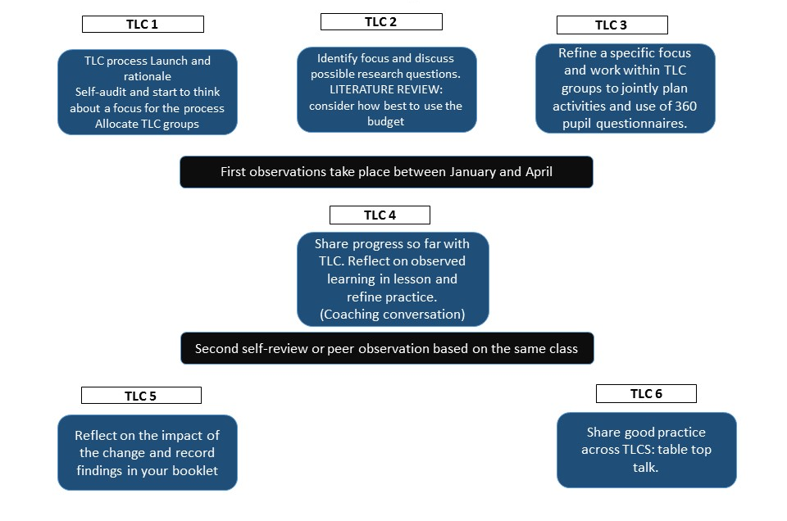

Definition of Action Research

Is a disciplined process of inquiry conducted by and for those taking the action. The primary reason for engaging in action research is to assist the professional in improving and/or refining his or her practice.

Action Research Cycle

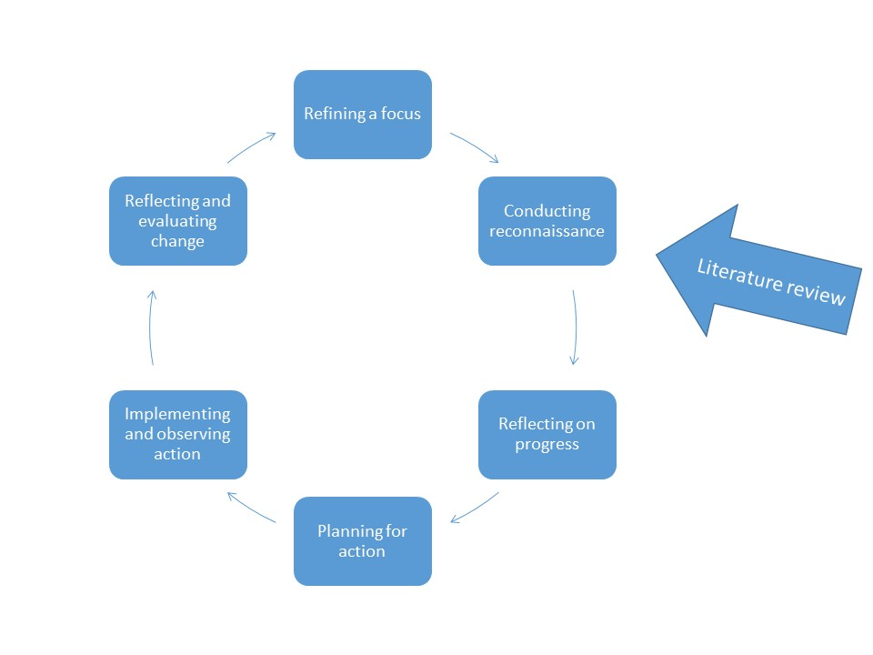

Lesson Study is a form of action research which originated in Japan. The main premise of lesson study is to work together in a group of collaborative study to plan the learning. When the observation takes place teachers identify just 3 students to observe so the observer focusses on the LEARNING rather than the teaching.

TLC meeting 1: Action Research focus:
Teaching and Learning Audit
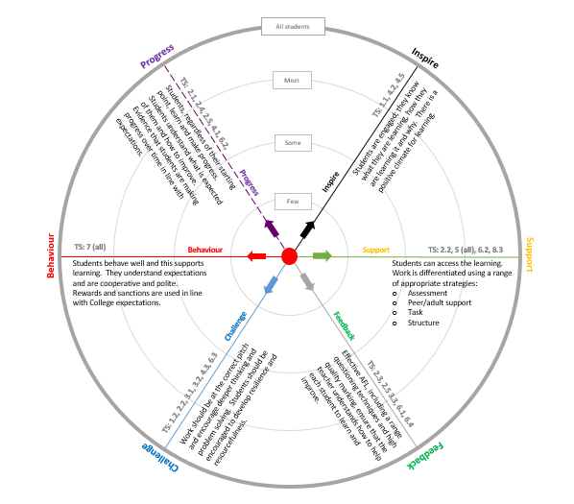
To be completed by teacher to help you chose a focus in readiness for the TLC session on the 5th December

In terms of T&L the area I would like to focus on is:

Initial Thoughts about a focus

I would like to improve ____________________________________
I am perplexed by _________________________________________
I am really curious about ___________________________________
Something I think would really make a difference is ___________
Something I would like to change is _________________________
What happens to student learning in my classroom when I ______?
How can I implement ______________________________________?
How can I improve ________________________________________?

What do you hope to achieve from the AR process?
Example:
Does planning structured DIRT (dedicated improvement and reflection time) enable the boys in my Y9 set 3 French class act on the feedback I give them to write longer extended sentences? How do I know this? (If they write in green pen do then then go on to act on what they have written?)
My Response:

What areas/teacher standards do you need to work on to achieve this?
2.3 guide pupils to reflect on the progress they have made and their emerging needs.

TLC meeting 2: literature Review based on your broad focus.
To inform your action research you can read blogs, tweets and books. There are some ideas shared on the reading list but this is by no means exhaustive. You will have a small budget in your TLCs to make a bid to buy some reading materials.
Here you can keep a log of any materials you have read to support your Action Research.

Item | Brief description | Impact

TLC meeting 3: Refining a focus and Action Plan.
To be completed at the initial meeting with your research group
Record of discussion related to GROW model
 | Possible questions | NOTES
GOALS | What is the goal you have set yourself?  How will you know when you have been successful?  What does success look like?  Why do you want to achieve this goal?  How important is it for you to achieve this? Why?
REALITY | Talk me through what’s happening now with this class.  What led up to you choosing this focus?  What barriers or obstacles might you face?  What influenced you to take this focus?  How might this affect teaching in our department and the outcomes for students?  Is your focus sufficiently narrow? (have you defined key terms? i.e. what is ‘effective’)
OPTIONS | So what are your options now?  If you didn’t have any restrictions or constraints what would you do?  What other approaches might bring you success with this?  What might your pupils/ colleagues suggest?  What techniques could you use to measure this? Can you ensure this is feasible/ measurable?
WAY FORWARD | What actions are you going to take?  When are you going to start?  Who will help you?  What methods will you use? Questionnaires/observations?  How are you going to make sure you do it?

Action Pan
Agreed Action | Support Required | Success Criteria
Plan and diary time to read some blogs or research relating to my focus | Reading list on share point | Have clear idea of what enables pupils to act on feedback based on current educational research.
Conduct a pupil questionnaire / focus group to ascertain a baseline of their perception of feedback they receive and how they can translate that into progress. | None – lesson time | Collate and understand current pupil perceptions on feedback

Action research plannning questions
Research question/focus
What do I/we want to change or improve?

What do I/we want to find out?

How might I/we do this? (How will I know if I have met my aim / answered my question?)
- HVC 360 Pupils questionnaires
- Focus groups
- Work sample
- peer observation
- Lesson diary
- Video the lesson
- Other:

Desired outcomes

Key Dates
 | Activity | Staff | Date
QA Check & Interim Review
QA Check & Final Review

Record of Observation
To be completed by the observer during the lesson.
Focus:
What do I/we want to change or improve?

Who was involved in the lesson study? (Students, focus group, control group)

Methodology. (What learning took place in the lesson to meet your objective?)

Learning taking place during the observed lesson:

What are the main findings/outcomes from your research/lesson and how will they impact on your future practice?

What further questions have arisen from your research/lesson study, if any?

What sources/materials were useful in supporting your research/lesson?

Data for the observed lesson (please attach).

TLC meeting 4: Reflecting on the learning in the observed lesson
To be completed following the initial observation
Record of discussion related to GROW model
 | Possible questions | NOTES
GOALS | What is the goal you have set yourself?  How will you know when you have been successful?  What does success look like?  Why do you want to achieve this goal?  How important is it for you to achieve this? Why?
REALITY | Talk me through what’s happening now with this class.  What barriers or obstacles did you face?  Did the activity you planned have the effect you had hoped for?  How might this affect teaching in our department and the outcomes for students?  Did the teaching in your lesson have the effect on the learning that you had intended?
OPTIONS | So what are your options now?  If you didn’t have any restrictions or constraints what would you do?  What other approaches might bring you success with this?  What techniques could you use to measure the outcome?
WAY FORWARD | What actions are you going to take next?  When are you going to start?  How will you adapt your planning and delivery?  What methods will you use? Questionnaires/observations?  How are you going to make sure you do it?

Action Plan: what will you do differently?
Agreed Action | Support Required | Success Criteria
Refer back to targets for improvement highlighted in previous DIRT and encourage students to notice progress over time | Planning time, discussion with action research partner | Boys in Y9 class can see what they have done differently in order to produce better work. They discuss how they can improve explicitly with the teacher.

Key Dates
 | Activity | Staff | Date
QA Check & Interim Review
QA Check & Final Review

Self Review/ second peer observation:
Teaching and Learning Audit
To be completed as an aid to help you reflect on the impact of the changes you made and planned

TLC meeting 5: Outcome of the AR process: Findings
To be discussed with your TLC group at TLC 5 in preparation to share with the rest of the staff at the sharing session at TLC 6.
Focus: What do I/we wanted to change or improve?

Who was involved in the lesson study/research? (Students, focus group, control group)

Lesson study methodology.

What are the main findings/outcomes from your research/lesson and how will they impact on your future practice?

What further questions have arisen from your research?

What sources/materials were useful in supporting your research/lesson?

Data for the observed lesson.

Reading List
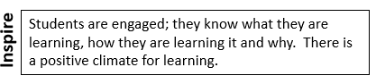

- Visible Learning and the Science of How We Learn, John Hattie and Gregory Yates.
- Why don’t students like school?: A cognitive scientist answers questions about how the mind works, Daniel T Willingham
- Pimp your lesson: Prepare, Innovate, Motivate and Perfect, Isabella Wallace and Leah Kirkman
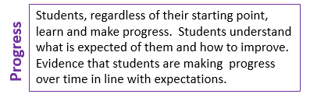
- Visible Learning and the Science of How We Learn, John Hattie and Gregory Yates.
Growth Mindset:
http://www.ted.com/talks/carol_dweck_the_power_of_believing_that_you_can_improve?language=en
http://www.mindsetworks.com/webnav/whatismindset.aspx
http://www.teacherstoolbox.co.uk/Dweck_Motivation.html
http://www.mindsetworks.com/
Dweck, C. S. (2012). Mindset: How You Can Fulfill Your Potential. Constable & Robinson Limited.
Dweck, C. S. (2006). Mindset: The new psychology of success. New York: Random House.
Dweck, C. S. (1999). Self-theories: Their role in motivation, personality and development. Philadelphia: Psychology Press.
Elliot, A. J., & Dweck, C. S. (Eds.). (2005). Handbook of competence and motivation. New York: Guilford.
Heckhausen, J., & Dweck, C. S. (Eds.). (1998). Motivation and self-regulation across the life span. Cambridge: Cambridge University Press
Growth Mindset Pocketbook. Hymer and Gershon.
Ready-To-Use Resources For Mindsets in the Classroom. Mary Cay Ricci.
Grit: Passion, Perseverance, and the Science of Success. Angela Duckworth.
Educating Ruby, what our children really need to learn, confidence, curiosity, collaboration, communication, creativity, commitment and craftsmanship, Guy Claxton and Bill Lucas.

Building Learning Power. Guy Claxton.
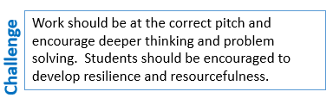
- https://drive.google.com/folderview?​id=0B0mu0B8e64j1fnV3SjB4VGtMX0lwWkVZOWVVMEJSVlBOeVFIdXl2SVRhRi1PcjhIdGI3STQ&usp=sharing A literature review compiled by Carl Hendrick of Wellington College on Growth Mindset and Grit
- http://geoffpetty.com/for-teachers/questioning/ a blog on questioning techniques in teaching
- http://teachertools.londongt.org/?page=questioningTechniques
- Grit: Passion, Perseverance, and the Science of Success. Angela Duckworth.

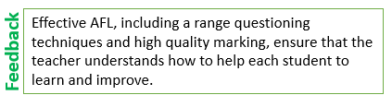
- https://educationendowmentfoundation.org.uk/public/files/Publications/EEF_Marking_Review_April_2016.pdf a collection of the research to date on different areas by the Education Endowment Fund.
- Dylan Williams an overview: http://www.teachwire.net/news/time-to-reassess-the-correct-way-to-use-formative-assessment
- Dylan Williams. See this 2 minute video for an outline: http://www.journeytoexcellence.org.uk/videos/expertspeakers/formativeassessmentdylanwiliam.asp
- or his website: http://www.dylanwiliam.org/Dylan_Wiliams_website/Welcome.html)
- Guy Claxton who talks about Building learning power: https://www.youtube.com/watch?v=WlYRhoWtoiM
- Visible Learning and the Science of How We Learn, John Hattie and Gregory Yates.
- Talk Less Teaching, Practice, Participation and Progress, Isabella Wallace and Leah Kirkman.
- How To Use Assessment For Learning in the Classroom, The Complete Guide, Mike Gershon (Chapter Seven)
- Embedded formative assessment, Dylan William (chapter 5).
- Making feedback count: https://headguruteacher.com/2012/11/10/mak-feedback-count-close-the-gap/
- http://www.teachertoolkit.me/2016/06/05/assessment-after-levels/
- How to not mark but still make feedback powerful (English Specialist): https://readingallthebooks.com/2016/03/19/giving-feedback-the-michaela-way/

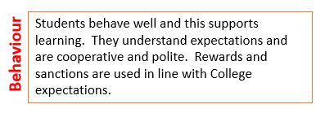
Behaviour for Learning
- Guy Claxton who talks about Building learning power: https://www.youtube.com/watch?v=WlYRhoWtoiM
- Grit: Passion, Perseverance, and the Science of Success. Angela Duckworth.
- Building learning Power: helping young people become better learners, Guy Claxton
- The Learning Powered School, Pioneering 21st Century Education, Guy Claxton, Maryl Chambers, Graham Powell and Bill Lucas.

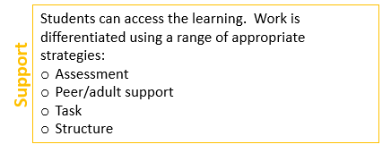
- Improving the context for inclusion: Personalising Teacher development through Action Research. Andy Howes, SMB Davies and Sam Fox

Action Research:
- Inside/outside: Teacher Research and Knowledge. Marilyn Cochran-Smith, Susan Landy Lytle
- Action Research, The Challenges of Understanding and Changing Practice. Townsend.
- A Handbook for Teacher Research, from design to implementation. Lankshear and Knobel.
- A Teacher’s Guide to Classroom Research. David Hopkins

- Lesson Study: Professional learning for our time. Peter Dudley

Other titles of interest:
- http://www.economist.com/news/briefing/21700385-great-teaching-has-long-been-seen-innate-skill-reformers-are-showing-best?fsrc=scn/tw/te/pe/ed/teachingtheteachers What interventions are most effective in the classroom (In terms of teacher time and value for money)
- This Much I Know about Love Over Fear…… Creating a Culture For Truly Great Teaching, John Tomsett.
- Creative Schools, Revolutionizing Education from the Ground Up, Ken Robinson.
- Teaching Backwards, Andy Griffith and Mark Burns.
- https://headguruteacher.com/2016/03/19/focusing-our-teaching-and-learning-priorities-a-reading-list/ A reading list of reading lists.

Notes

